

**Info Sheet**

* Developer: Team Cherry
* Release Date: February 24th 2017
* Resolution & Frame-rate: 1920 x 1080, 60fps
* Availability: PC, Mac, Linux, Nintendo Switch, Playstation 4, Xbox One.
* Website: [hollowknight.com](http://hollowknight.com/)
* Developer Website: [teamcherry.com.au](http://teamcherry.com.au/)
* Press Contact: press@teamcherry.com.au
* Social: [Twitter](https://twitter.com/TeamCherryGames) | [Facebook](https://www.facebook.com/teamcherrygames)

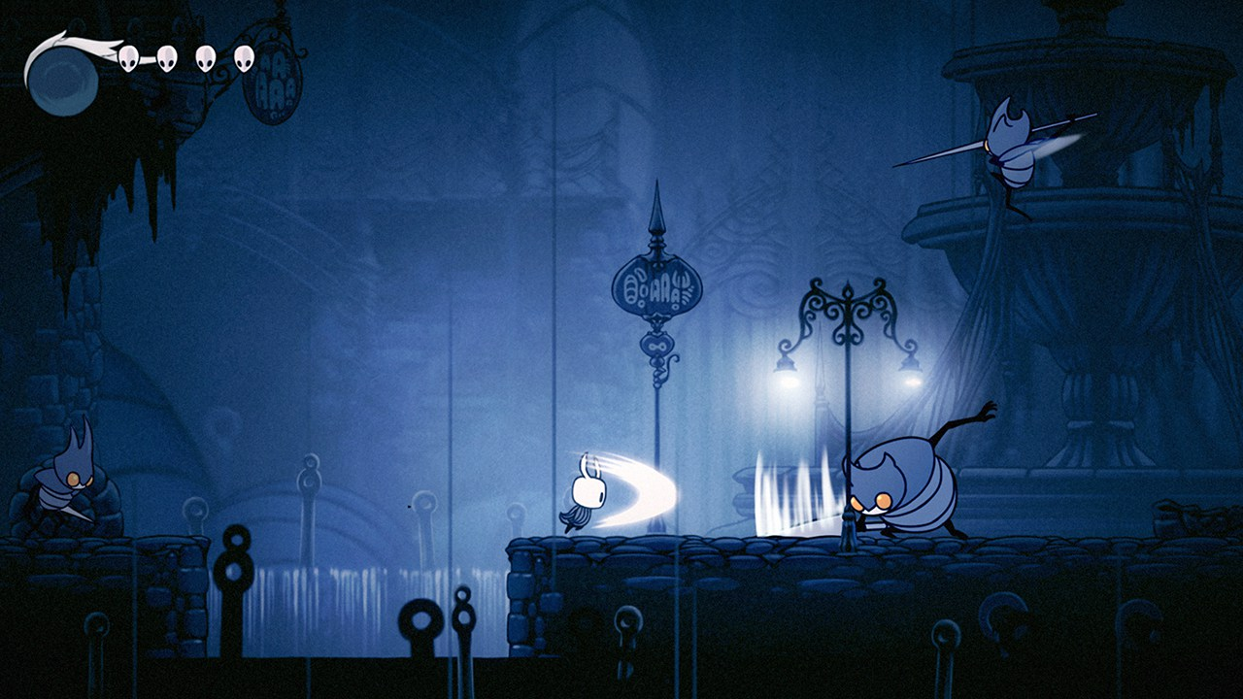

*Venture down into a beautiful, ruined world of insects and heroes.*

*Beneath the fading town of Dirtmouth sleeps an ancient, forgotten kingdom. Many are drawn beneath the surface searching for riches, or glory, or answers to old secrets. As the enigmatic Hollow Knight, you’ll traverse the depths, unravel its mysteries and conquer its evils.*

Hollow Knight is an epic 2D action-adventure. You’ll explore twisting caverns, battle tainted creatures and escape intricate traps, all to solve an ancient long-hidden mystery.

* Explore vast, Inter-connected Worlds
* Encounter a bizarre collection of friends and foes
* Evolve with powerful new skills and abilities
* Evocative Hand-Drawn Art

The world of Hollow Knight is brought to life in vivid, moody detail, its caverns alive with bizarre and terrifying creatures, each animated by hand in a traditional 2D style.

Every new area you’ll discover is beautifully unique and strange, teeming with new creatures and characters to discover. The world of Hollow Knight is one worth exploring just to take in the sights and discover new wonders hidden off of the beaten path.

**Features**

* Classic side-scrolling action, with all the modern trimmings.
* Tightly tuned 2D controls. Dodge, dash and slash your way through even the most deadly adversaries.
* Explore a vast interconnected world of forgotten highways, overgrown wilds and ruined cities.
* Forge your own path! The world of Hallownest is expansive and open. Choose which paths you take, which enemies you face and find your own way forward.
* Evolve with powerful new skills and abilities! Gain spells, strength and speed. Leap to new heights on ethereal wings. Dash forward in a blazing flash. Blast foes with fiery Soul!
* Equip Charms! Ancient relics that offer bizarre new powers and abilities. Choose your favourites and make your journey unique!
* An enormous cast of cute and creepy characters all brought to life with traditional 2D frame-by-frame animation.
* Over 140 enemies! 30 epic bosses! Face ferocious beasts and vanquish ancient knights on your quest through the kingdom. Track down every last twisted foe and add them to your Hunter's Journal!
* Leap into minds with the Dream Nail. Uncover a whole other side to the characters you meet and the enemies you face.
* Beautiful painted landscapes, with extravagant parallax, give a unique sense of depth to a side-on world.
* Chart your journey with extensive mapping tools. Buy compasses, quills, maps and pins to enhance your understanding of Hollow Knight’s many twisting landscapes.
* A haunting, intimate score accompanies the player on their journey, composed by Christopher Larkin. The score echoes the majesty and sadness of a civilisation brought to ruin.
* Complete Hollow Knight to unlock Steel Soul Mode, the ultimate challenge!

**About the Developer**



Hollow Knight is the first release by Team Cherry. Our tiny team initially formed around game jams, but we really bonded over our love for Zelda 2. Though we’ve all worked on games in the past, Hollow Knight is the culmination of the things we love in games. Its cute and creepy, quaint and epic; a giant, strange world to explore and conquer.

**Ari Gibson**

Ari is the co-founder of Team Cherry. He’s worked on countless projects across film, games, music videos and advertising. Thanks to Hollow Knight he now knows an awful lot about bugs.

**William Pellen**

William has been designing and building games for years, and is co-founder of Team Cherry. He loves to create silly little worlds for people to poke around in and explore. He’s been enraptured with games ever since his Dad found the wing boots for him in Zelda 2, and wants to recreate that experience of adventure and excitement for other people.

**Dave Kazi**

Dave is Hollow Knight’s Technical Director. He comes from a background in development and project management. Having worked on many challenging projects, he’s decided to exchange the corporate life to embrace the world of creativity and pursue his passion for everything video games.

**Matthew ‘Leth’ Griffin**

Matt will be handling PR and marketing for the game in the lead-up to release and during the post-launch window. He’s previously worked in this role for Stardew Valley, Interstellaria and Wanderlust Adventures. Matt is also a legit game creator, working as the main coder for Wanderlust and the online-multiplayer coder for procedural platformer Risk of Rain.

Contact Leth at [press@teamcherry.com.au](mailto:press@teamcherry.com.au)